Wordle

LEGAL NAME LEONARD-ADRIAN BUNEA
PREFERRED NAME ZOE MCFIFE
TIME SPENT 04:25:21

Table of Contents
Table of Contents 1
Table of Figures 2
Exercise 1 – File I/O and Error Handling 3
Solution Idea 3
Code 3
Test 4
Exercise 2 – Input Validation 6
Solution Idea 6
Code 6
Test 8
Exercise 3 -Feedback Calculation 9
Solution Idea 9
Code 9
Test 11
Exercise 4 – Autosolve Feature 12
Solution Idea 12
Code 12
Test 13
Exercise 5 – Complete Game Implementation 15

Table of Figures
Figure 1: Read Words 4
Figure 2: Global Words Class 4
Figure 3: reading words 5
Figure 4: Reading Words 5
Figure 5: Word Reading Failure 5
Figure 6: getStringInput Method 7
Figure 7: validateGuess Method 7
Figure 8: enterGuess Method 8
Figure 9: Guessing Tests 8
Figure 10: computeGuess 10
Figure 11: Guess 11
Figure 12: Wordle 11
Figure 13: finding Hints 13
Figure 14: HELP! 13
Figure 15: TWANG 14
Figure 16: Main Menu 15
Figure 17: Help 15
Figure 18: Wordle 16

Exercise 1 – File I/O and Error Handling

Solution Idea
One can use a buffered reader to read a CSV file. I also save the words in memory and the guesses in a HashSet so looking for a valid word is more efficient. I exit the program inside the catch clause if the CSV file isn’t found or able to be read.

Code
/**
* Reads a CSV file and returns a set of words.
*
* @param file The path to the CSV file.
* @return A set of words read from the file.
*/
public static Set<String> readCsvFile(String file)
{
Set<String> words = new HashSet<>();
try (BufferedReader reader = Files.newBufferedReader(Path.of(file)))
{
String line;
// Skip header
reader.readLine();
while ((line = reader.readLine()) != null)
{
line = line.trim().toLowerCase();
if (!line.isEmpty())
{
words.add(line);
}
}
}
catch (IOException e)
{
System.err.println("Error reading file: " + file);
System.err.println(e.getMessage());
System.err.println("Make sure the file exists and is accessible. Program will exit.");
System.exit(1);
}
return words;
}
Figure 1: Read Words

/**
* Global class to store valid Wordle words.
*/
public class Words
{
/**
* List of valid Wordle solution words.
*/
public static List<String> validSolutions = new ArrayList<String>();
/**
* Set of valid Wordle guess words. Using a set for O(1) lookup time.
*/
public static Set<String> validGuesses = new HashSet<>();
}
Figure 2: Global Words Class

Test
public static void main(String[] args)
{
WordleWordReader.readWordleWords();
IO.println(Global.Words.validGuesses);
IO.println(Global.Words.validSolutions);
}
Figure 3: reading words
Figure 4: Reading Words
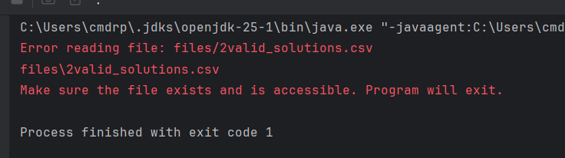
Figure 5: Word Reading Failure

Exercise 2 – Input Validation

Solution Idea
First, I created a method that uses IO.readln to read in a String, if the String is empty, longer than maxLength or shorter than minLength, it reprompts the user to enter their input. Inside the enterGuess method there’s a check, that looks up if the entered guess is contained inside the guess HashSet.

Code
/**
* Gets a string input from the player with minimum and maximum length restrictions.
* Continues to prompt until valid input is provided.
*
* @param prompt The prompt message to display
* @param minLength The minimum allowed length of the input
* @param maxLength The maximum allowed length of the input
* @return The validated string input
*/
public static String getStringInput(String prompt, int minLength, int maxLength)
{
while (true)
{
IO.println(prompt + ": ");
String input = IO.readln().trim();;
if (!input.isEmpty() && input.length() <= maxLength && input.length() >= minLength)
{
return input;
}
if (input.length() > maxLength)
{
printlnRed("Input exceeds maximum length of " + maxLength + " characters. Please try again.");
}
else if (input.length() < minLength)
{
printlnRed("Input must be at least " + minLength + " characters long. Please try again.");
}
else
{
printlnRed("Input cannot be empty. Please try again.");
}
}
}
Figure 6: getStringInput Method

private boolean validateGuess(String guess)
{
return Words.validGuesses.contains(guess);
}
Figure 7: validateGuess Method
private Guess enterGuess()
{
do
{
String currentGuess = UI.getStringInput("Enter your Guess", Config.MAX_WORD_LENGTH, Config.MAX_WORD_LENGTH
).toUpperCase();
if (currentGuess.equals(Config.EXIT_COMMAND))
{
return new Guess("EXIT!", new GuessAccuracy[0]);
}
else if (currentGuess.equals(Config.HELP_COMMAND))
{
UI.printlnRed("Not implemented yet.");
}
if (validateGuess(currentGuess))
{
return computeGuess(currentGuess);
}
else
{
UI.printlnRed("Invalid Guess. Please try again.");
}
}
while (true);
}
Figure 8: enterGuess Method

Test
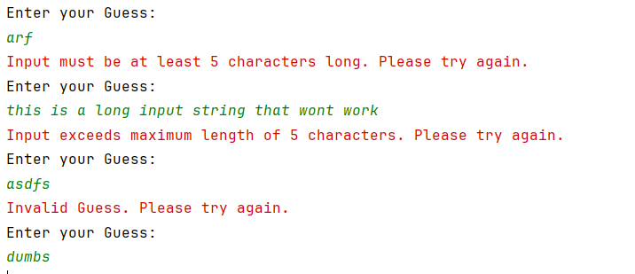
Figure 9: Guessing Tests

Exercise 3 -Feedback Calculation

Solution Idea
Guesses are stored as pairs of a String and an array of GuessAccuracies, which is an enum with “CORRECT, WRONG_POSITION, INCORRECT” as values. Calculating how accurate the guess is, is done in two passes. In the first pass, it just checks if any letters are already in the correct position and stores those letters. In the second pass it checks for any incorrectly positioned letters. If the letter appears in the word, it adds a WRONG_POSITION GuessAccuracy, otherwise INCORRECT. The GuessAccuracies get displayed as different colors when the guesses are printed to the console.

Code
private Guess computeGuess(String guessedWord)
{
GuessAccuracy[] accuracies = new GuessAccuracy[Config.MAX_WORD_LENGTH];
boolean[] letterUsedInPickedWord = new boolean[Config.MAX_WORD_LENGTH];
// First pass: Check for correct letters in correct positions
for (int i = 0; i < Config.MAX_WORD_LENGTH; i++)
{
if (guessedWord.charAt(i) == pickedWord.charAt(i))
{
accuracies[i] = GuessAccuracy.CORRECT;
letterUsedInPickedWord[i] = true;
}
}
// Second pass: Check for correct letters in wrong positions
for (int i = 0; i < Config.MAX_WORD_LENGTH; i++)
{
if (accuracies[i] == null)
{
boolean found = false;
for (int j = 0; j < Config.MAX_WORD_LENGTH; j++)
{
if (!letterUsedInPickedWord[j] && guessedWord.charAt(i) == pickedWord.charAt(j))
{
found = true;
letterUsedInPickedWord[j] = true;
break;
}
}
accuracies[i] = found ? GuessAccuracy.WRONG_POSITION : GuessAccuracy.INCORRECT;
}
}
return new Guess(guessedWord, accuracies);
}
Figure 10: computeGuess

public class Guess
{
private final String word;
private final GuessAccuracy[] accuracies;
public Guess(String word, GuessAccuracy[] accuracies)
{
this.word = word;
this.accuracies = accuracies;
}
public void printGuess()
{
for (int i = 0; i < word.length(); i++)
{
char letter = word.charAt(i);
GuessAccuracy accuracy = accuracies[i];
switch (accuracy)
{
case CORRECT -> UI.printGreen(String.valueOf(letter));
case WRONG_POSITION -> UI.printYellow(String.valueOf(letter));
case INCORRECT -> UI.printGray(String.valueOf(letter));
}
}
UI.printBlankSeparatorLine();
}
public String getWord()
{
return word;
}
public GuessAccuracy[] getAccuracies()
{
return accuracies;
}
}
Figure 11: Guess

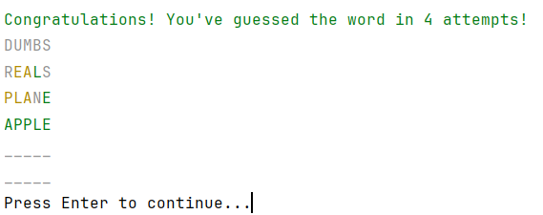
Test
Figure 12: Wordle

Exercise 4 – Autosolve Feature

Solution Idea
I just look through every word and if a yet unguessed letter is in the correct position of the word, I use that word as the guess. I also shuffle the words list before, so the guesses are more varied.

Code
private Guess findHintGuess()
{
char[] missingLetters = getMissingLetters();
char[] emptyArray = new char[Config.MAX_WORD_LENGTH];
for (int i = 0; i < emptyArray.length; i++)
{
emptyArray[i] = Config.PLACEHOLDER_LETTER;
}
if (Arrays.equals(missingLetters, emptyArray))
{
UI.printlnRed("No missing letters to provide hints for.");
UI.delayMedium();
return computeGuess("APPLE");
}
UI.printlnYellow(Arrays.toString(missingLetters));
UI.delayMedium();
List<String> words = new ArrayList<>();
words.addAll(Words.validGuesses);
Collections.shuffle(words);
for (String word : words)
{
int availableHints = Config.HINT_ACCURACY;
IO.println(word.length() + " " + word);
for (int i = 0; i < word.length(); i++)
{
if (missingLetters[i] != Config.PLACEHOLDER_LETTER)
{
if (word.charAt(i) == missingLetters[i])
{
availableHints--;
if (availableHints <= 0)
{
return computeGuess(word);
}
}
}
}
}
UI.printlnRed("No more hints available. Entering APPLE as default guess.");
UI.delayMedium();
return computeGuess("APPLE");
}
Figure 13: finding Hints

Test
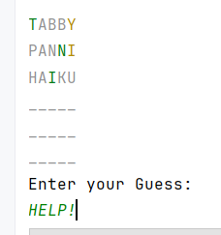
Figure 14: HELP!

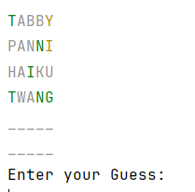
Figure 15: TWANG

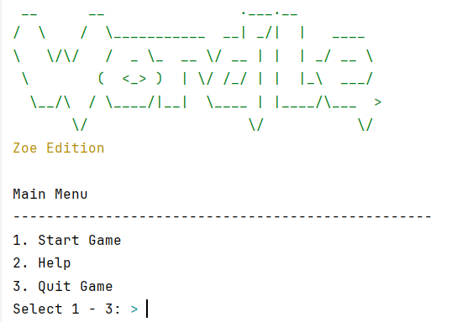
Exercise 5 – Complete Game Implementation
Figure 16: Main Menu
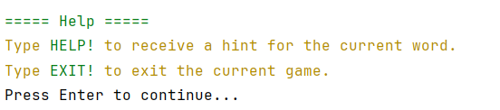
Figure 17: Help

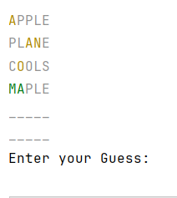
Figure 18: Wordle

